2020 National Craft Championships
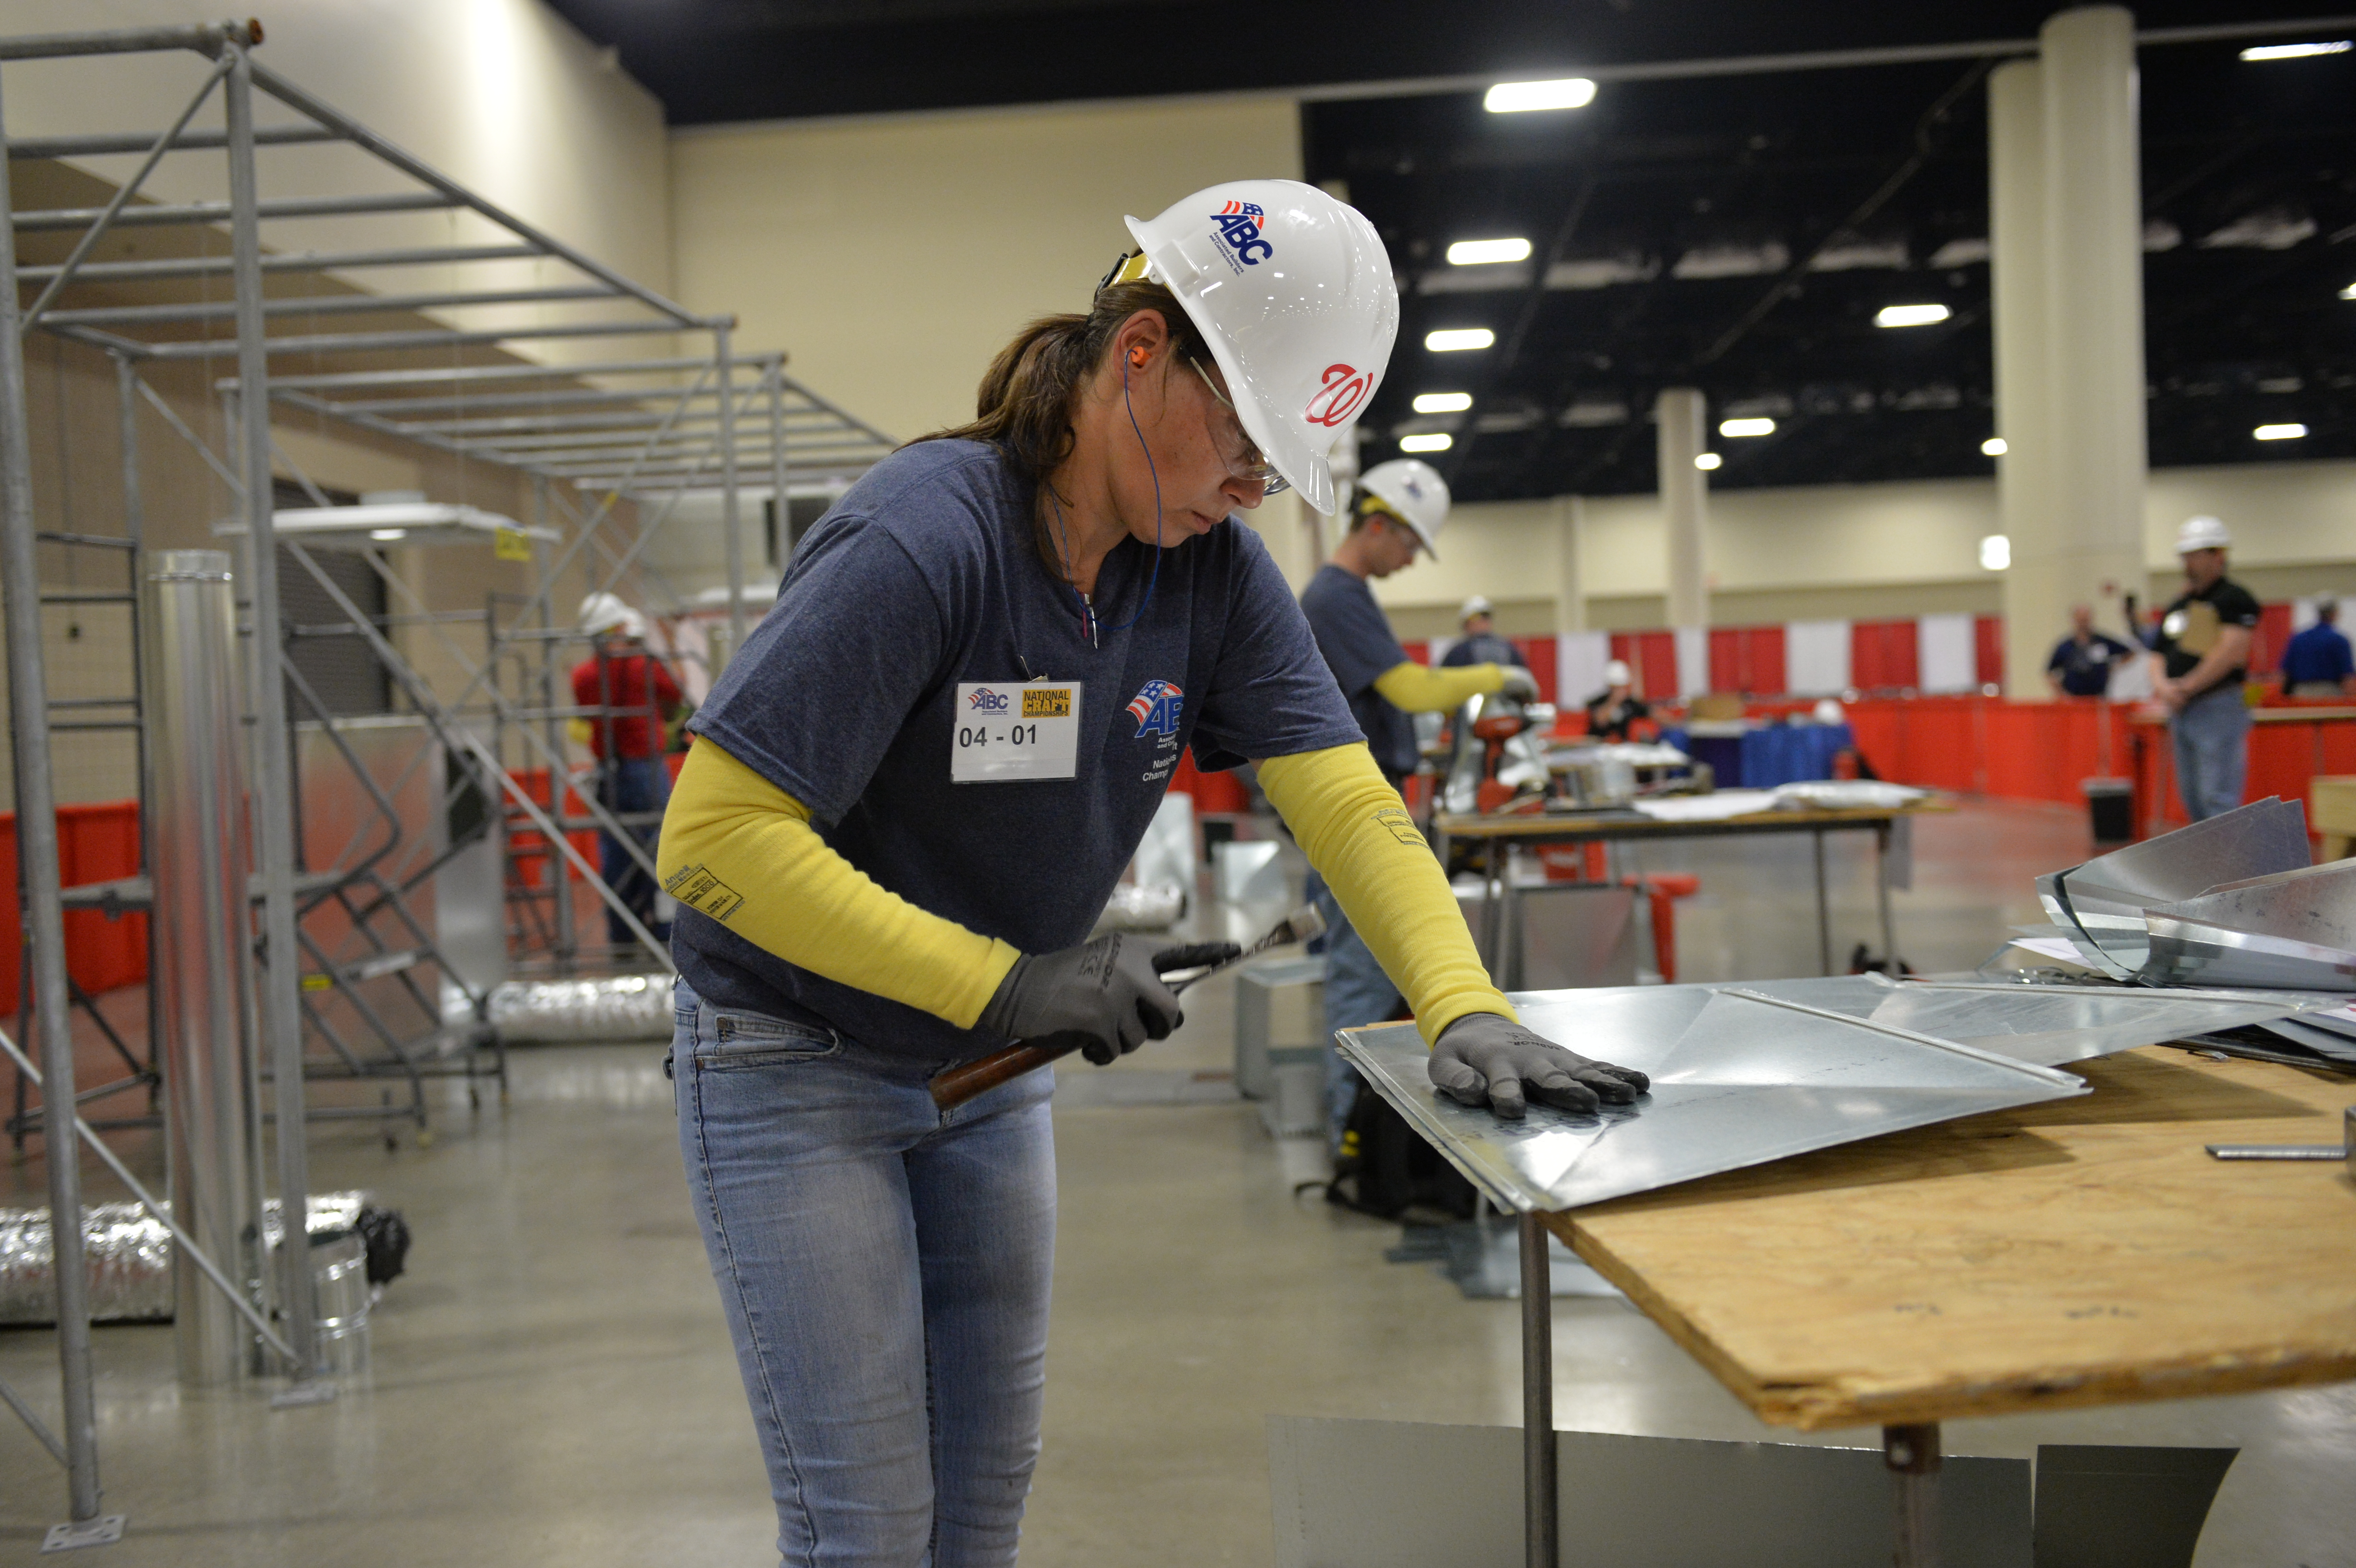
Guidebook

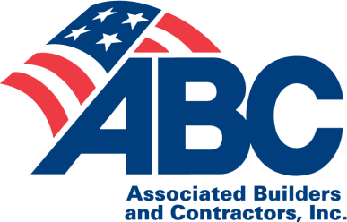
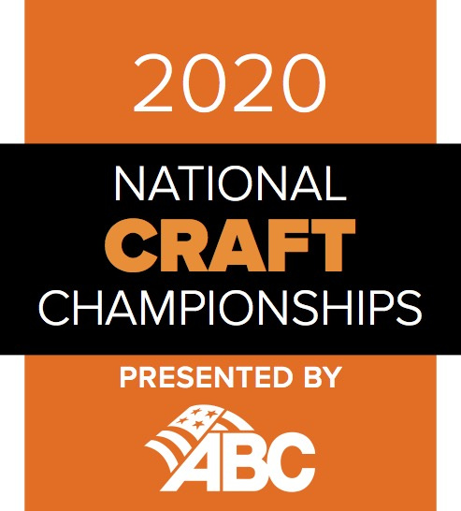
IIntent to Compete due Dec. 1, 2017
Competitor Registration due Jan. 12, 2018

March 18-22, 2018
Long Beach, Calif.
Table of Contents

Section 1: National Craft Championships Page 2
  - Overview
  - National Craft Championships Committee Roster
  - Tentative Schedule of Events

Section 2: Competitors Page 4
2.1 Overall Eligibility (also refer to specific competition eligibility in the craft fact sheets)
2.2 Selection Recommendations
2.3 Expenses
  - Guests

Section 3: National Craft Championships Competitions Page 6
3.1 Procedures
- Competitor Orientation
- Written Exam
- Practical Performance Test
3.2 Disqualification/Points Deduction
3.3 Changes During the Exam or Test
3.4 Spectator Guidelines
3.5 Disassembly and Clean-up
3.6 Scoring
3.7 Awards and Recognition
3.8 Issues, Conflicts and Concerns

Section 4: Safety Page 12
4.1 Safety Orientation
4.2 Personal Protective Equipment (PPE)
4.3 Set-up and Disassembly
4.4 Jewelry
  - Electronic Devices
  - Safety Judging
4.7 First Aid

Section 5: Forms Page 14
5.1 Deadlines
5.2 Intent to Compete: Due Dec. 13, 2019
5.3 Competitor Registration(s): Due Jan. 24, 2020
5.4 Competition Cancellation Policy

Craft Fact Sheets and Safety Scopes Page 15

Carpentry: Residential-Commercial
Commercial Metal Stud Framing and Drywall
Electrical: Residential-Commercial
Electrical: Commercial-Industrial
Fire Sprinkler
HVAC
Instrumentation Fitting
Insulation
Millwright/Industrial Maintenance Mechanic
Pipefitting

Plumbing
Power Line Worker
Sheet Metal
Pipe Welding
Structural Welding
Team Competition: Commercial
Team Competition: Industrial

Section 1: National Craft Championships

1.1 Overview

Presented by Associated Builders and Contractors and (ABC), the National Craft Championships (NCC) is planned and conducted annually by the NCC Committee, comprised of member contractor representatives and ABC chapter and national staff. Serving as project managers, members of the NCC Committee work with experts from contractor organizations to design, manage and conduct individual competitions. Each competition consists of a written exam and a practical performance test modeled on the Contren® Learning Series curricula developed by NCCER.

The NCC Committee’s mission is to provide all competitors with a fair and equal opportunity to succeed and win, as well as promote a rewarding learning experience throughout the competitions. As you review the information in this guidebook, contact Lisa Nardone, NCC director, (202) 595-1789, or the project manager listed below for more information.

1.2 2018-2019 National Craft Championships Committee Roster

Ronnie Balentine Project Manager, Pipefitting (281) 960-0037 balentrd@sbec.com

Evan Banda Assistant PM, Electrical (909) 721-3682 ebanda@championelec.com

Diane Koester-
Byron Executive Committee Liaison (760) 294-7097 dbyron@iepacific.com

Bill Cherry Project Manager, Pipe Welding (281) 460-2670 bdcherry@sbec.com

Mitch Clark Past Chair, Project Manager, HVAC (602) 558-1618 mclark@comfortsystems.com

Dave Dekelaita Assistant PM, Electrical (727) 235-9091 ddekelaita@powerdesigninc.com

Timothy Ely Project Manager, Electrical (513) 309-1586 tim.ely@beacon-electric.com

Milton Graugnard Executive Committee Liaison (225) 754-0213 miltong@cajunusa.com

Jimmy Greene Chapter President Liaison (989) 213-4367 jgreene@abcgmc.com

Stacy Gunderson Project Manager, Drywall Demo (210) 657-4437 stacygunderson@marekbros.com

Derek Herr Project Manager, Carpentry (610) 322-7753 dherr@wohlsen.com

Bill Lastinger Vice Chair, Project Manager,
Commercial Team (717) 278-1346 wlastinger@benchmarkgc.com

Michael Leyva Project Manager, Millwright (515) 357-8343 mleyva@keenprojectsolutions.com

John Lupacchino Assistant PM, Electrical (317) 716-7051 jlupacchino@gaylor.com

Lisa Nardone Director, ABC National (703) 638-3261 nardone@abc.org

Jan Prakke Project Manager, Plumbing (352) 661-0356 jprakke@gulfmc.net

Mike Raven Project Manager, Instrumentation (207) 679-7119 mraven@cianbro.com

Ralph Riley Project Manager, Safety (713) 582-6749 rdriley@sbec.com

Jon Sacks Project Manager, Power Line (207) 416-8264 jsacks@cianbro.com

Steve Sjolander Project Manager, Insulation (608) 780-7955 steves@lcinsulation.com

Natalie Smith Event Coordinator (352) 871-5560 natalie.smith@kbr.com

Shon Smith Chair, Project Manager, Sheet Metal (515) 509-8443 ssmith@acimech.com

Greg Spenner Chapter President, Member (515) 681-6100 greg.spenner@abciowa.org

Mike Stilley Safety Manager (281) 541-8887 mlstilley@sbec.com

David Victor Project Manager, Fire Sprinkler (443) 974-1861 dbvictor@vscfs.com

Chris Weber Project Manager, Structural Welding (504) 458-2306 chrisweber@abcbayou.com

  - Tentative Schedule of Events*
*Competitor attendance is required for all events listed on this schedule

Day of Week | Start Time | End Time | Event Name
Tuesday, March 24 | 8:00 AM | 5:00 PM | Registration
Wednesday, March 25 | 8:30 AM | 11:00 AM | Written exam make-up with prior approval
Wednesday, March 25 | 11:30 AM | 4:00 PM | NCC Lunch and Orientation
Wednesday, March 25 | 4:15 PM | 5:15 PM | NCC/CMC Reception
Wednesday, March 25 | 5:30 PM | 6:45 PM | Opening General Session
Wednesday, March 25 | 7:00 PM | 9:30 PM | Opening Night Party
Thursday, March 26 | 6:45 AM | 7:45 AM | NCC Breakfast
Thursday, March 26 | 8:00 AM | 3:00 PM | NCC Practical Performance Tests
Thursday, March 26 | 11:00 AM | 12:00 PM | NCC Lunch
Thursday, March 26 | 3:00 PM | 4:00 PM | Competitor Break
Thursday, March 26 | 4:00 PM | 6:45 PM | Practical Performance Tests Disassembly and Clean-Up
Friday, March 27 | 2:30 PM | 4:00 PM | NCC Round-Up
Friday, March 27 | 4:30 PM | 6:00 PM | Careers in Construction Awards Ceremony (Free and Open to All).
Friday, March 27 | 6:15 PM | 9:00 PM | Closing Night Party

Section 2: Competitors

2.1 Overall Eligibility

NCC competitors must be trainees or students. They must be enrolled in and soon to be completing a training program. Training programs should include formal craft training and/or registered apprenticeship programs as well as written exams and practical performance tests. To be eligible to compete in the NCC, a trainee must meet the following requirements as well as the specific competition eligibility requirements described in the competition fact sheets.

- Be actively enrolled and sponsored by an ABC chapter, ABC member firm (in-house) or ABC chapter-approved training program within nine months prior to the NCC.

- Must not be certified as a journeyman more than six months prior to the date of the NCC. A journeyman is defined as 1) holding a journeyman license from any state, city, county or municipality; or 2) holding a U.S. Department of Labor journeyman’s credentials; or 3) being compensated as a journeyman.

- Possess no more than six years total experience in the competition being entered (not including secondary school programs).

- Did not compete within the same craft competition in any previous ABC National Craft Championships (formerly ABC Craft Olympics). In addition, a competitor who competes in one of the NCC electrical competitions is not eligible to compete in the other NCC electrical competition.

- The following policy ensures all competitors are equally prepared to compete in a competition setting and possess sufficient hands-on experience for the necessary regard for their own safety and those of others in the competition: Any craft training student who has not previously been employed or is not currently employed by a construction-related firm must be approved to compete by the NCC Committee.

- There is no limit to the number of eligible competitors an ABC chapter, chapter-approved training program or member firm may send to the competition. To ensure adequate materials are available at the time of the competition, all competitor space reservations must be submitted no later than Dec. 13, 2019. Some competitions have size limitations and space reservations will be accepted on a first-come, first-served basis with every effort to accommodate the maximum number of competitors possible.

- A competitor’s training sponsor must complete and submit an intent-to-compete form no later than Dec. 13, 2019. Intent-to-compete forms will not be accepted after this date, and all fees are non-refundable should a competitor drop for any reason. In addition, a competitor registration form for each competitor must be submitted by Jan. 24, 2020.

- Meet all specific competition eligibility requirements as described in the competition fact sheets.

2.2 Selection Recommendations

- Each chapter, company or chapter-approved training sponsor program is responsible for selecting its competitors.

- A chapter, company or chapter-approved training program may hold its own local craft competition or select competitor(s) according to recommendations outlined in this section. While it is not necessary to hold a preliminary local craft competition, it is encouraged in order to create the spirit and sense of competition that will be advantageous when competing in the NCC.

- Regardless of the selection method, all competitors must meet the eligibility requirements and comply with the policies and procedures outlined in this guidebook.

- It is strongly recommended that all trainees/students complete no less than 250 hours of training before being selected to compete in the NCC.

- Other recommended methods for selecting competitors are:
- Instructor recommendation;
- Highest grade point average and attendance record;
- Contest using a written exam – highest scores determine competitor(s);
- Contest with both a written exam and a practical performance test – highest scores determine competitor(s);
- Contest with both a written exam and a practical performance test – judges use criteria to determine competitor(s).

2.3 Expenses

Chapter, Member, Sponsor and Employer Contributions

Chapter, member, sponsor and employer contributions fund the intent-to-compete fee ($1,000 per competitor paid with the intent-to-compete form), airfare, ground transportation, hotel, certain meals and any other miscellaneous expenses.

  - Guests

Please remember to assist in making arrangements for spouses and other guests. Because many competitors have not traveled before, you may want to provide them with information on airfare, additional airline fees, ground transportation, hotel accommodations, meals and registration fees for their guests.

Guests can register on the ABC Convention 2020 website. Fill in the guest’s name and email address, choose Convention/EIC registration category and GUEST as the registration type. Guest ticket options follow.

Full Social Event Ticket $475
Opening General Session
Opening Night Party
NCC Viewing & Lunch
Association Excellence Awards
Careers in Construction Awards Ceremony
Closing Night Party

Opening Night Celebration $175
Opening General Session
Opening Night Party

Closing Night Celebration $175
Careers in Construction Awards Ceremony
Closing Night Party

Day Pass—No charge
Access to the exhibit hall and NCC. Lunch may be purchased at the concession stands.

For more information, contact Lisa Nardone, (202) 595-1789 or nardone@abc.org.

Section 3: National Craft Championships Competitions

3.1 Procedures

Competitor Orientation
A competitor orientation session will be held on Wednesday, March 25. Attendance is mandatory for all competitors. The orientation will include the following components:

- Project managers will provide an overview of the practical performance tests, the judging process and attendance at the awards ceremony.
- A safety overview will discuss expectations, safety practices, first-aid procedures and review the safety portion of the practical performance test.
- Equipment representatives will provide an overview of equipment operations and special features.

Written Exam

Important news for 2020—The written exam must be completed before competitors arrive onsite. Exceptions will be made for extreme circumstances with prior approval of the NCC director via email. If an exception is granted, the make-up exam will take place Wednesday, March 25, 8:30 a.m.-11 a.m. and be proctored onsite by NCCER. Only those competitors with prior approval from the NCC director will be allowed to take the test onsite. All competitors must sit for the written exam or face disqualification from the NCC. The written exam continues to make up 25 percent of one’s overall competition score.

Competitors will complete the written exam at a local NCCER Accredited Assessment Center prior to arriving onsite. It is the responsibility of the sponsor organization to schedule test sessions directly with NCCER by emailing a request to: NCCTest@nccer.org SUBJECT: Schedule NCC Test.

NCCER will contact the sponsoring organization to provide access to the written test in NCCER's Online Testing System. Information on accessing the Testing System will be provided including requirements for the testing proctor.

All exams/tests are based on the standardized craft training process. In addition to the knowledge and skills required for each competition, all competitors should have completed the NCCER Contren® Learning Series Core Curriculum modules. A non-programmable calculator will be provided for the written exam, but no reference materials are permitted.

FAQs

- When will the tests be available?
  - Testing must take place between January 24 – March 13, 2020
- I am not an NCCER Accredited Assessment Center. How will my competitors get tested?
  - NCCER will facilitate finding an assessment center in your area.
  - Instructions will be sent to the sponsor contact on how to register your competitor(s) for testing.
- How will I access tests for my competitors?
  - NCCER will send instructions to the Accredited Assessment Centers where testing has been scheduled.
  - NCCER will be providing job aids and step-by-step instructions for each testing location.
- How do I request for tests to be assigned to my competitors?
  - NCCER will send out registration information based on the competitor registration list provided by ABC National/NCC.
  - NCCER will pre-assign tests to each competitor.
  - Pre-assignment will be made based on the testing registration information provided to NCCER.
- Is there a fee for the test?
  - NCCER will not be charging any fee for the NCC exams.
  - NCCER will work with Accredited Assessment Centers to waive any proctoring/administration fee for the NCC exams.
- Is there an opportunity for a “test run” of the testing system to make sure we are ready to administer the test?
  - Yes, NCCER’s testing system has a sample test that can be given.
  - Information for requesting a sample test will be included in the test registration process.
- What do I do if I have a technical issue during testing?
  - NCCER provides testing emergency/technical support Monday-Friday, 7:00am-9:00pm EST.
  - Call 888-622-3720 for support.
- What if my testing time falls outside of these hours?
  - Testing date and time will be part of the test registration process. If you will be testing outside of the standard NCCER support hours, you can note that need on the test registration and NCCER will ensure that they have a support agent available to you for your designated testing date/time.
- Will my competitor or I know the test score?
  - No. Test scores are only available to ABC National/NCC.

- All questions will be based on the Contren® Learning Series and may include all training levels.

- The written exam will be administered in English. If a competitor cannot read/follow instructions in English, contact the NCC director in advance of arriving onsite to determine if any reasonable accommodations can be made.

- The use of non-programmable calculators and other reference materials will be at the individual project manager’s discretion. (If a calculator is permitted, it will be provided.) Loose notes will not be permitted. All reference materials are subject to inspection.

- Competitors will have two (2) hours to complete the exam.

- No competitor cellular telephones, pagers, tablets, laptops, smart watches or other electronic devices will be allowed in the testing room. Competitors will be asked to surrender all electronic devices prior to the start of the written exam.

- The use of tobacco, including smokeless and electronic products, is prohibited.

Practical Performance Test
- All verbal communication will be conducted in English. If a competitor cannot read/follow instructions in English, contact the NCC director in advance of arriving onsite to determine if any reasonable accommodations can be made.

- Project managers will have the option to perform a tool and equipment check for each competitor.

- The use of non-programmable calculators, code manuals and other reference materials will be at the project manager’s discretion. (If a calculator is permitted, it will be provided.) All reference materials are subject to inspection.

- Prior to the scheduled start time, competitors will have the opportunity to review the inventory of provided materials.

- The NCC director or a designated representative will sound a horn to announce the start and end of the practical performance test. Competitors will have six (6) hours to complete the test.

- No cellular telephones, pagers, tablets, laptops, smart watches or other electronic devices will be allowed in the testing room. Competitors will be asked to surrender all electronic devices prior to the start of the practical performance test.

- All competitors are required to participate in all NCC activities. Note: After the practical performance test disassembly, competitors will be dismissed no later than 6:45 p.m.

- The use of tobacco, including smokeless and electronic products, is prohibited.

3.2 Disqualification/Points Deduction

A competitor may be disqualified from the NCC or have points deducted from his/her score for any of the following reasons:

- Misrepresenting experience level or any falsified information on the competitor registration form.

- Violating eligibility requirements.

- Being absent or tardy for the competitor orientation, opening session, written exam, practical performance test, or disassembly and clean-up.

- Cheating, as determined by the respective judges, project manager and/or other NCC Committee members.

- Failing to prominently display the assigned competitor identification number on outer clothing during the practical performance test.

- Failing to return all components of the written exam and/or practical performance test.

- Leaving the practical performance test area without permission from a judge or project manager.

- Failing to participate in the disassembly/clean-up phase following the practical performance test.

- Failing to comply with clothing and personal protective equipment (PPE) requirements as stated in Section 4 of this guidebook.

- Removing documents, tools, materials or equipment from the exam/test areas without proper authorization.

- Violating safety procedures as determined by the judges or project manager. Refer to page 12 of this guidebook for further explanation.

- Being under, or giving the appearance of being under, the influence of any psychoactive substances or acting in an unprofessional/impaired manner.

Any disqualified competitor will automatically forfeit their competition rank as well as any accompanying recognition, awards, medal, prizes and cash.

3.3 Changes During the Exam or Test

During both the written exam and the practical performance test, competitors may bring to the attention of their project manager any discrepancies with the competition materials or equipment. The project manager and judges will determine the most appropriate action(s) to resolve the discrepancy and make a final ruling.

3.4 Spectator Guidelines

During the practical performance test, spectators are allowed to watch the competitors perform, but should observe the following guidelines:

- Spectators are to remain within designated spectator areas and are not permitted to enter the practical performance test areas for any reason.

- Spectators are not permitted to speak with competitors or judges during the test nor pass any objects (including food or drink) to the competitors.

- Coaching is not allowed by anyone during the practical performance test. Competitors also may not be coached during breaks and/or the lunch period.

- Guests are not allowed to have lunch with the competitors during the practical performance test.

- Spectators are not permitted in the test site during set-up or disassembly.

- When taking photographs, caution should be taken when using a flash attachment. An unexpected flash is distracting and could result in a competitor making a serious mistake.

- Spectators should direct any questions to the project manager. Spectators may not talk to the judges.

- All spectators (including competitor guests, chapter/company representatives and other visitors) must exit the exhibit hall immediately after the conclusion of the practical performance test.

3.5 Disassembly and Clean-Up

When a competitor has completed the practical performance test, the following procedures must be completed:

- Upon expiration of the six-hour time limit, the NCC director or designated representative will announce the conclusion of the practical performance test. At that time, all work must stop.

- Competitors must return all test materials and related documents to their project manager or his designated representative.

- Judges will convene at the test site to finalize the scores.

- Once the project manager has collected all scores and test materials, he or she will excuse the judges.

- All competitors are required to participate in the disassembly/clean-up of the entire test site. Note: Competitors will be dismissed no later than 6:45 p.m.

- All tools and materials must be collected and properly stored.

- The area must be broom-swept of all debris.

- Project managers will ensure that competitors clean each test area properly and prepare all materials for shipping. After inspecting each test area, the NCC director or designated representative will instruct competitors to move to a central location where they will be dismissed from the test area as one group.

Note: Competitors are still being judged during disassembly/clean-up activities and are subject to disqualification or deduction of points for safety violations.

3.6 Scoring

Each competition is composed of two parts–a written exam and a practical performance test. The scores from these two components will be combined as follows:

- The written exam is based on the Contren® Learning Series curricula and will account for 25 percent of the total score. See the scoring criteria chart on the following page.

- The practical performance test will account for 75 percent of the total score. See the scoring criteria chart on the following page.

- Within the practical performance test, there will be 40 possible safety-related points and 160 competition-related points, for a total of 200 points. The written exam will represent a possible 100 points, comprised of both safety and competition-related questions.

- The ranking of each competitor is determined by combining the weighted written exam score and the weighted practical performance test score.

- All competitor scores are confidential and will not be made public. Following the competition, upon request only, training sponsors will receive competitor performance summaries without identifying information for those competitors who participated in competitions having 10 or more participants. (If a competition was conducted with less than 10 participants, performance summaries for that competition will not be distributed to protect the anonymity of competitors.) Summaries will provide rankings for each competitor in comparison to the other competitors in the competition. Numerical scores or rankings will not be provided.

Scoring Criteria Chart
Competition Component | Total Possible Points | Percent of Total Score
Written Exam | 100 points | 25%
Practical Performance Test | 200 points (40 safety/160 competition) | 75%

Tie Breakers
In the event that competitors in a single competition have tie scores and those scores place one or more of the competitors in contention to receive a medal, the following four methods will be implemented in succession until the tie is broken, determining final medal placement:

Tie Breaker #1: Highest overall practical performance test raw (un-weighted) scores.
Tie Breaker #2: Highest practical performance test raw (un-weighted) safety scores.
Tie Breaker #3: Results of tiebreaker practical exercise as specified by project managers on each competition’s score sheet.
Tie Breaker #4: Line-by-line analysis of competitors’ score sheets until a difference occurs.

3.7 Awards and Recognition

All competitors are required to participate in the Opening General Session and the Careers in Construction Awards Ceremony (see the Schedule of Events). Competitors will be honored at the awards ceremony, and winners for each competition will be announced. (To the extent possible, the chapters, companies, chapter-approved training programs and employers of the winners will be recognized during the ceremony.) The scoring criteria chart determines the final placement of each winner. Medals, tools and cash awards will be presented for each competition as follows:

Competition Rank | Cash Prize Amount | Award
First Place | $750 | Gold Medal
Second Place | $500 | Silver Medal
Third Place | $350 | Bronze Medal

Note: Although it is the NCC Committee’s intention to award three medals in each competition, the number awarded may drop below three if a competition is approved to be conducted with four participants or fewer in any given year. The NCC Executive Committee will monitor the competition process and determine whether all competition participants meet the minimum performance standards on the written exam and practical performance test, as set forth by the NCC Committee, before awarding medals in that competition. Minimum performance standards not only apply to test scores, but also include putting forth a genuine effort during the competition, exhibited by attitude, focus, professionalism and work ethic in accordance with the merit shop philosophy.

The Internal Revenue Service considers cash awards taxable income. All competitors will be required to complete an IRS W-9 form.

3.8 Issues, Conflicts and Concerns

Occasionally, during a competitive event of this magnitude, the chapter, company, chapter-approved training program or a competitor may have questions about competition results, competitive processes used or judging procedures. In the event that issues, conflicts or concerns arise, the following procedure will be used to resolve the situation:

- Competitors should direct all questions to their competition project manager during the practical performance test.

- Competitors, the chapter, company or chapter-approved training program should notify the appropriate project manager as soon as a concern is raised. The nature of the concern should be clearly explained. In turn, the project manager will use this guidebook as a reference in responding in a timely manner. Depending on the complexity of the issue, the project manager may request the concern be submitted in writing to the NCC director.

- If the project manager cannot immediately resolve a concern, it will be referred to the NCC Executive Committee comprised of the chair, chair-elect, past chair, safety manager, director, chapter president liaison and the respective competition project manager, provided there is no conflict of interest. Should a conflict of interest arise, the Executive Committee member will remove/recuse himself/herself from the proceedings. Depending on the nature and extent of the concern, it may be necessary to submit the concern in writing to the director for referral to the NCC Executive Committee, which has the final authority in resolving all issues and will take into consideration fairness to all competitors and adherence to established procedures.

Section 4: Safety

4.1 Safety Orientation

A safety program containing a general safety overview and safe work practices will be conducted during the competitor orientation. Attendance is mandatory for all competitors.

4.2 Personal Protective Equipment (PPE)

All personal protective equipment (PPE) must be appropriate for the task and meet current ANSI standards, which have been incorporated into the Occupational Safety and Health Administration (OSHA) PPE regulations as follows: Eye and Face Protection ANSI Z87.1; Head Protection ANSI Z89.1; and Foot Protection ANSI Z41.1. There are no ANSI standards for gloves; however, selection must be based on the performance characteristics of the glove in relation to the tasks to be performed or as selected and/or provided by the competition project manager or defined on the competition “tools required” list.

During the practical performance test, ABC will provide and require the proper use of the following personal protective equipment for all competitors:

- Ear protection;
- Safety glasses;
- Hard hat (except for welders); and
- General work gloves (may not apply to all competitions – see task-specific gloves below).

Exceptions to the provided PPE, with prior approval from the project manager, are:

- Prescriptive safety glasses with side shields;
- Prescriptive goggles; and
- Task-specific gloves per industry standards, designed to protect against sharp edges or high heat.

Competitors must provide and use the following during both days of competition:

- Standard work shoes or boots (tennis shoes or sandals are not permitted);
- Blue jeans or work pants; and
- Shirts with sleeves, minimum four inches in length, (baggie or excessively loose-fitting clothing is not permitted).

  - Set-Up and Disassembly

All safety standards must be followed by competitors during competition set-up and disassembly. Competitors must use:
- Hard hat;
- Safety glasses;
- Standard work shoes or boots;
- General work gloves; and
- Hearing protection as needed and determined by the project manager.

  - Jewelry

Exposed jewelry is not permitted. Examples include (but are not limited to):
- Earrings (stud or dangling);
- Wrist watches;
- Rings;
- Studs exposed through the nose, jaw, lip, eyebrow or any visible part of the body; and
- Gauges (if gauges cannot be removed, they must be covered with tape).

  - Electronic Devices

No electronic devices will be allowed during any part of the competition except for those used by NCC Committee members and judges.

  - Safety Judging

Prior to the practical performance test, the competition project manager or judges may inspect each competitor’s personal hand tools, which must meet all Occupational Safety and Health Administration (OSHA) regulations and standards. For example, “mushroomed” heads on chisels are not permitted. Judges will be present during the practical performance test to score competitors in such safety areas as the use of personal protective equipment, hand and power tool safety, ladder safety, etc. Depending on the severity and/or frequency of a violation or violations, the judges, in consultation with the respective project manager, have the authority to disqualify competitors.

Note: Competitors are still being judged during disassembly/clean-up activities and are subject to disqualification or deduction of points for safety violations.

  - First Aid

All injuries, regardless of severity, must be reported to the project manager immediately. The project manager will contact the NCC chair or director to determine the appropriate action, including assistance by onsite EMT personnel.

Section 5: Forms

5.1 Deadlines

To participate in the NCC, a chapter, company or chapter-approved training program must complete and submit two forms: an intent-to-compete form and a competitor registration form. Timely completion of these forms confirms the number of competitors for each competition, allows sufficient time to obtain the necessary equipment, tools and materials to accommodate the number of competitors, and provides competitor information that will be published in advance of the event. Please be sure to complete and submit these forms promptly on or before the due dates. Your competitor(s) will be ineligible to compete if you fail to meet these deadlines. The intent-to-compete fee(s) must be paid Dec. 13, 2019. The deadline dates for these forms are:

- Intent-to-compete form due no later than Dec. 13, 2019.
- Competitor registration form due no later than Jan. 24, 2020.

5.2 Intent to Compete: Due Dec. 13, 2019

The intent-to-compete step determines the amount of space required for the competition as well as the necessary equipment, tools and materials. When completing this form, it is not necessary to provide specific competitor information, but you must indicate the competition(s) in which your competitor(s) intends to participate. Due to set-up and material costs for each competition, it is the expectation of the NCC Committee that a reservation for a particular competition will not be changed to another competition. Competition changes after Feb. 10 are strictly prohibited.

Please Note: Completion of the intent-to-compete form reserves space for your competitor(s). However, a competitor registration form also must be completed and submitted for each competitor.

5.3 Competitor Registration: Due Jan. 24, 2020

The competitor registration form provides specific information about the competitor, the competitor's chapter/company/chapter-approved training program and his/her employer. It also verifies that the competitor understands certain information about his/her competition responsibilities and must be submitted on time.

5.4 Competition Cancellation Policy
Although it is the NCC Committee’s intention to conduct all advertised competitions, a craft skills competition may be cancelled if five or fewer spaces are reserved at the first deadline. In the event of a competition cancellation, the chapter/company/chapter-approved training sponsor program will be notified no later than Jan. 10, 2020, and the $1,000 fee will be refunded.

In addition, a craft skills competition may be cancelled if a competition’s participation significantly falls after the competitor registration deadline. In this case, the NCC director would notify the chapter/company/chapter-approved training sponsor program immediately to reach a mutually agreed on resolution, taking into consideration several factors, including the financial investment up to that point.

Craft Fact Sheets and Safety Scopes

The NCC Committee is providing information for individual download at ncc.abc.org:

Fact Sheets & Safety Scope
Carpentry: Residential-Commercial
Drywall
Electrical: Residential-Commercial
Electrical: Commercial-Industrial
Fire Sprinkler
HVAC
Instrumentation Fitting
Insulation
Millwright/Industrial Maintenance Mechanic
Pipefitting
Plumbing
Power Line Worker
Sheet Metal
Team
Pipe Welding
Structural Welding

Forms
Intent to Compete Form
Competitor Registration Form

